Where is the male reproductive system located?
A. Pectoral region
B. Pelvis region
C. Abdominal region
D. Lumbar region
ANSWER: B
External opening of the urethra is called _______
A. penile urethra
B. pubic symphysis
C. prostatic urethra
D. urethral meatus
ANSWER: D
The testicles are located outside of the male body because
A. more sperm can be created.
B. the sperm have a shorter distance to travel during intercourse
C. there is no room to fit the testicles inside the body.
D. production of sperm best takes place at a temperature lower then body temperature
ANSWER: D
The ____________transports mature sperm to the urethra in preparation for ejaculation
A. Epididymis
B. Seminal vesicles
C. vas deferens
D. urethra
ANSWER: C
It carries and stores sperm cells that are created in the testes
A. Epididymis
B. Seminal Vesicles
C. Vas Deferens
D. Urethra
ANSWER: A
Which one of the following is not part of the male reproductive system?
A. Scrotum
B. Penis
C. Testes
D. Cervix
ANSWER: D
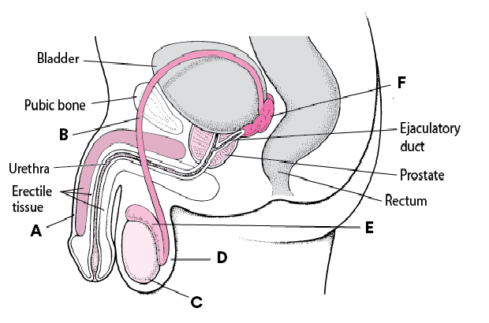
The diagram shows the male reproductive system, identify the structure labeled A:
A. Vas deferens
B. Epididymis
C. Penis
D. Testes
ANSWER: C

The diagram shows the male reproductive system, identify the structure labeled B:
A. Vas deferens
B. Epididymis
C. Penis
D. Testes
ANSWER: A

The diagram shows the male reproductive system, identify the structure labeled C:
A. Vas deferens
B. Epididymis
C. Penis
D. Testes
ANSWER: D

The diagram shows the male reproductive system, identify the structure labeled D:
A. Scrotum
B. Epididymis
C. Penis
D. Testes
ANSWER: A
The _________ is the loose pouch-like sac of skin that hangs behind the penis
A. Scrotum
B. Epididymis
C. Penis
D. Testes
ANSWER: A
Within the testes are coiled masses of tubes called:
A. Scrotum
B. Epididymis
C. Penis
D. Seminiferous tubules
ANSWER: D


The diagram shows the male reproductive system, identify the structure labeled E:
A. Scrotum
B. Epididymis
C. Penis
D. Testes
ANSWER: B
The _________ is the male organ for sexual intercourse
A. Vas deferens
B. Epididymis
C. Penis
D. Testes
ANSWER: C

The diagram shows the male reproductive system, identify the structure labeled F:
A. Epididymis
B. Seminal Vesicles
C. Vas Deferens
D. Urethra
ANSWER: B

